**How to fall asleep faster and sleep better**

We all have evenings when we find it hard to fall asleep or we wake up in the night. You may also find this is happening more often during the coronavirus (COVID-19) outbreak. Good-quality sleep makes a big difference to how we feel, mentally and physically, so it's important to get enough. The advice you will find here is a good way to get you thinking about your sleep and what may be stopping you from sleeping well. We also have some simple steps you can take to make a change.

**Create a restful environment**

Simple things can have a big impact when it comes to falling asleep and staying asleep.  
It's generally easier to drop off when it's cool, dark and quiet – but the right sleep environment is personal, so try different things and see what works for you.  
Wearing earplugs, putting your phone on silent and face down (or out of the room entirely), keeping clocks out of view and making sure the room is well ventilated can all make a big difference.  
Some people also find playing ambient sounds like rainfall, gentle music or white noise helpful.

**Manage your worries**

Concern or anxiety about the coronavirus outbreak is normal, but these feelings can affect how easily you fall asleep and how well you sleep.  
There are things you can do in your day to [help manage your worries](https://www.nhs.uk/oneyou/every-mind-matters/coronavirus-covid-19-anxiety-tips/), like talking to someone you trust and switching off from the news. If you often lie awake worrying, set aside time before bed to make a to-do list for the next day – this can be a good way to put your mind at rest.

Using techniques like reframing unhelpful thoughts might also help

**Get into a daily routine**

With everything happening at the moment, it’s likely your normal routine has been disrupted. Having a regular sleeping pattern is really important for good sleep.  
It may be harder to do right now, but if you can wake up, wind down, and go to bed around the same time each day, it will really help. If possible, avoid napping too.   
Your sleep routine starts before getting into bed, so build in time to wind down – and try to switch off from tech. Reading, gentle stretches, and meditation are a good way to unwind.

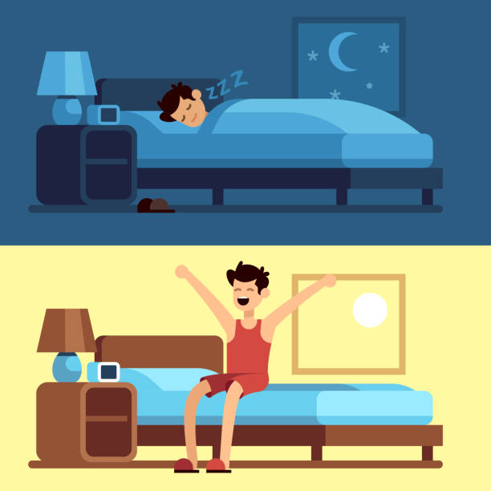

**Confront Sleeplessness**

If you’re lying awake unable to sleep, do not try to force it. If you’re tired and enjoying the feeling of resting, then sleep may naturally take over.

If not, get up and do something relaxing for a bit, like reading a book or listening to quiet music, and go back to bed when you feel sleepier.

**Prepare your body for sleep**

Our physical health and how we look after our body can have a big effect on our sleep. It can be easy to fall into unhealthy patterns of behaviour that can make your sleep worse, especially at times like these.

Having caffeine, alcohol, nicotine, or a big meal too close to bedtime can stop you falling asleep and prevent deep sleep. Try to avoid them before bed and see if things improve.

Regular exercise is also great for sleep. Just remember to steer clear of anything too vigorous right before bedtime if you find it affects your sleep, and make sure you follow the social distancing guidelines when exercising.



**How to do deal with change and uncertainty during COVID-19**

**We have all faced disruption, change and uncertainty during the coronavirus (COVID-19) outbreak, and that looks set to continue for a while.**

**It's easy to get caught in a spiral of "what ifs" – worrying about our health, family, job and finances, and how and when things will return to normal – particularly if we are already struggling with our mental health.**

**Here are 10 things you can do to help deal with change and look after your mental wellbeing in the face of uncertainty, as well as places you can go to get further free advice and**

**9. Only do what’s comfortable**As the situation evolves, it’s important to make sure we are going at our own pace. We should not let others pressure us into things that make us feel uncomfortable, anxious or unsafe – but we also have to try to not let that be an excuse that stops us from doing positive and beneficial things, like safely staying in touch with friends. It’s natural to have concerns, so discuss them with those close to you and try to build in small positive changes. It can be difficult to see others doing things without you. Perhaps your partner or child has gone back to work, for example, but you cannot. Honest and open communication is vital but so is giving others the space to move at their own speed.

**1. Take stock of how you feel**

Put time aside to examine your current situation and consider how you really feel, perhaps talking it through with someone you trust. Try to be kind to yourself, and get support with how you are feeling if you think you might need it.

**2. Focus on the short term**

The further we look into the future, the easier it is to get overwhelmed by the long-term uncertainty. Try to focus on the day-to-day, and think about what’s in your power to do right now.

**8. Decide what strategies work for you**

Think about what strategies have worked best for you when you have faced problems. It could be in the past, or what's worked recently. Maybe you've noticed going for a walk at lunch helps to clear your head, or maybe a catch-up with a friend makes you feel that bit brighter. Whatever it is, commit to making it part of your daily routine.

**7. Reframe your thoughts**

In difficult times like this, it can be easy to get caught up in negative thoughts. For most people, at this time, feeling uneasy is an understandable response to everyday life. You might find yourself in a negative spiral where you fixate on issues and convince yourself of the worst. It can be helpful to step back, examine the evidence for your thoughts and explore other ways of looking at the situation. This can help to break the negative spiral.

**5. Find a new rhythm**

Routine and structure can be a powerful way to regain consistency and reduce uncertainty. Make time to de-stress and wind down each day –build in positive activities like exercise, relaxation, hobbies, speaking to friends, and think about a positive sleep routine.

**4. Recognise your achievements**

Take 10 minutes and list some of your accomplishments over the last 12 months – no matter how big or small. Are there any unexpected ones in there? Getting by in the face of one of the biggest challenges the world has faced in many years is a big achievement in itself. Be proud.

**3. Acknowledge what’s working**

Even when it might feel like everything is going wrong, there will be some things that don’t change. It could be a close relationship, our favourite meal, or a song that means something to us. Noticing acknowledging and being grateful for these can help us deflect and recover from life’s knocks. Each day consider what went well and try to list 3 things you’re thankful for.

**6. Try to stay in the moment**

The situation is changing frequently, it’s important not to focus on the past, the future, or get bogged down by things you cannot know. You can only do your best with what you have today. Relaxation, mindfulness and the outdoors are helpful to focus on the present.

**10. Get practical advice**Talk to people you trust and get support if you need it. There is lots of help out there. If you're worried about your employment or housing, then find out about your rights. It can be hard, but try to face your fears and get help. Citizens Advice is a good place to start. For advice on how to look after your mental health in the workplace, or support others [Mental Health At Work](https://www.mentalhealthatwork.org.uk/) has a range of resources and information.

If you're [worried about bills or debt](https://www.nhs.uk/oneyou/every-mind-matters/coping-money-worries-and-job-uncertainty-during-covid-19/), the best thing you can do is talk to an expert and make a plan.

**Share your feelings but do not compare**

Being able to share your feelings can help with loneliness, and hearing a familiar voice or seeing a friendly face makes us feel less isolated.

Telling someone you trust that you’re feeling lonely can help, this may be easier to do when you’ve had some time to chat and relax together.

Many people only share the good things happening on social media, avoid comparing yourself to anyone as this can make you feel lonelier. Plus we can never be sure what someone else is going through./var/folders/v0/8cvgzvws7vb72w9503xyvld00000gn/T/com.microsoft.Word/WebArchiveCopyPasteTempFiles/ACwAAAAAAQABAAACADs=

**Volunteer to help others**

Another way to stay busy is by helping others, which can also boost your mental wellbeing. You can volunteer during the coronavirus outbreak from home or in your community, but follow the government guidelines if you are going out. If you would prefer to help others from home, you could volunteer to be a phone buddy to someone. Some charities run groups, like [Age UK's Call in Time](https://www.ageuk.org.uk/services/befriending-services/sign-up-for-telephone-befriending) that put volunteers in touch with people to call for a chat and see how they're doing. You may even make new friends while volunteering.

**Be more social and check in regularly**

Create a regular routine of checking in with others, as it can make it easier to reach out at a time when you may feel lonely.  
Try messaging old friends or colleagues on social media, or set up a group chat if you prefer to talk with a few people at the same time. Most of us love hearing from people we have lost contact with – and that's especially true now. It may also encourage people to contact you more.

**Be more social and check in regularly**

There are lots of ways to reach out to friends and family. Chatting on the phone, video-calling and using social media can remind you that you’re not alone.

Some things you could do online together include; watching films, playing scrabble or having dinner. You could join one of the many online clubs and virtual social events taking place, and invite your friends and family to take part too.

**Stay busy by learning something new**

Now is a good time to pursue a hobby or something you have always wanted to be able to do – and it can be a good way to spend time with others.   
  
You could join an online class for arts and crafts, cookery, DIY or gardening. Become a guitar hero, learn piano or join a virtual choir.

If you want to do something that gets you thinking, you could try learning a new language.

**Do more things you enjoy**

Filling your time doing more things you like can stop you from focusing on feelings of loneliness and is good for your wellbeing.  
If you can go out, a trip to the park can help, but always follow social distancing guidelines when you are outside your home.  
When you're at home, entertaining radio shows or podcasts are a good way to occupy your mind and keep you company. You could listen to audiobooks, and join an online book club to talk about them with others. There are also lots of comedy clubs online.

You might be missing family and friends, colleagues or other everyday connections you had. It's natural to feel like this, and you should not blame yourself for feeling like you are struggling, now or at any other time

**What you can do if you feel lonely in the coronavirus outbreak**

The coronavirus (COVID-19) outbreak has made it harder to be with others. Contact with family and friends continues to be limited, and social and leisure activities are restricted, which can cause feelings of loneliness – particularly if you are [staying at home](https://www.gov.uk/government/publications/covid-19-stay-at-home-guidance/stay-at-home-guidance-for-households-with-possible-coronavirus-covid-19-infection).  
  
  
  
It's really important to remember these changes will not be forever. If you're feeling lonely at the moment, the following tips can help. Different things work for different people, so try to find what suits you, and seek further support if you feel you need it.