You are invited to a free, informal, half day course to support your recovery and rehabilitation after cancer. The focus of this event is the psychological and emotional consequences of going through cancer diagnosis and treatment. However, the content is flexible and your priorities will be discussed.

Living Well with and Beyond Cancer
(Half-day course)

Date | Time | Location | Venue
Tuesday 3rd December 2019 | 10:00 – 14:00 | Barrow | Wainwright Suite, Age UK, Barrow, LA14 1XL.
Wednesday 8th January 2020 | 10:00 – 14:00 | Lancaster | The Cornerstone, Sulyard St, Lancaster LA1 1PX
Tuesday 4th February 2020 | 10:00 – 14:00 | Kendal | Meeting Room, Enterprise House, LA9 6NZ
Tuesday 3rd March 2020 | 10:00 – 14:00 | Barrow | Wainwright Suite, Age UK, Barrow, LA14 1XL.
Wednesday 8th April 2020 | 10:00 – 14:00 | Lancaster | The Cornerstone, Sulyard St, Lancaster LA1 1PX
Tuesday 5th May 2020 | 10:00 – 14:00 | Kendal | Meeting room, Enterprise House, LA9 6NZ
Tuesday 2nd June 2020 | 10:00 – 14:00 | Barrow | Wainwright Suite, Age UK, Barrow, LA14 1XL.
Wednesday 8th July 2020 | 10:00 – 14:00 | Lancaster | The Cornerstone, Sulyard St, Lancaster LA1 1PX
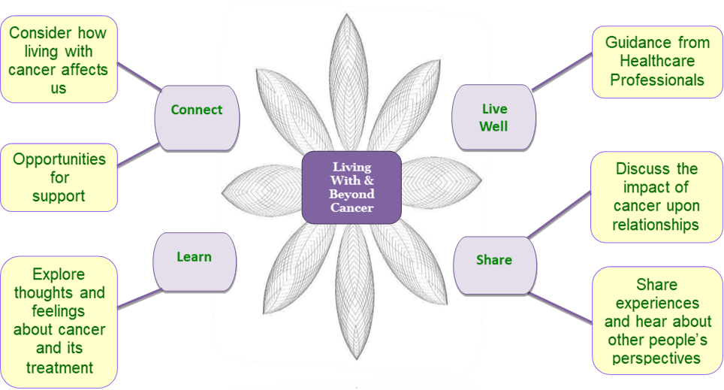

Family and friends are welcome. Lunch & refreshments provided.
If you would like to attend or have any questions, you can book your place by speaking to your Specialist Nurse/Care Coordinator. If you have any questions, or cannot access the internet, then please contact our clinical support team on 01768 245 954 who will be happy to help you with the booking process.

