My Reflections/ Plan

**What have I already tried? Did it help?**

**What barriers have I faced? What barriers**

**do I still face?**

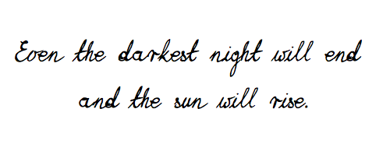

**What are my next steps? What else might help me?**