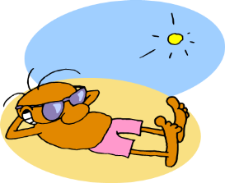

**5. STRESS BUSTERS**

Relaxation, meditation & mindfulness

Taking time out, holidays and breaks

Exercise, yoga, swimming

Having fun, laughing, spending time with friends

Eating regular healthy meals

Develop good sleep habits

Put yourself first once in a while!

*4. SIGNS OF STRESS*

*Muscle tension and headaches*

**4. SIGNS OF ON-GOING STRESS**

Muscle tension and pain

Headaches

Poor concentration and memory

Poor sleep pattern

Weight gain or loss

Bladder and bowel irritability

Mood changes

Behaviour change eg withdrawn

Smoking or drinking more

Anxiety and panic attacks

3. Things that stress the body include:

* Pain
* Family upset
* Relationship issues
* Work
* Financial worries
* Bereavement
* Moving house
* Illness or injury
* Everyday hassles
* Finding a car park space
* Playing high stakes computer games

In fact just about anything in the right circumstances. Stress is defined as demands placed upon us in excess of our perceived ability to cope with them.

1. **THE HUMAN STRESS RESPONSE IS DESIGNED FOR SHORT TERM USE ONLY - FIGHT, FLIGHT OR FREEZE FOR SURVIVAL**

ADRENALINE AND CORTISOL DO THE FOLLOWING:

Increase heart rate and blood pressure

Increase respiratory rate

Increase blood clotting

Slow down digestion

Reduce blood supply to hands/feet and internal organs

Damp down immune response

Damp down reproductive system

Increase alertness and focus but reduce memory storage and logical thought

**2. STRESS CHEMICALS**

**5 THINGS YOU SHOULD KNOW ABOUT STRESS**